1. **INTRODUCTION:**

Apple has introduced a new sensor in the iPhone’s camera module. And,it has already introduced a new biometrice sensor in the previous generation of the device.The rate of innovation in the smartphone industry has slowed, with decreasing number of substantial improvements from one device to the text.

Siphons on multiple fronts including a slick hardware design, faster processor, better resolution displays and significantly improved camera modules. Together, all these improvements in the latest iPhones 6 and Plus are designed to provide a great experience to the user. The next set of innovations in smartphones is expected to be the sensor space. Most importantly, sensors working in tandem. And, tandem-working sensors are fundamental for wearable computing.

* 1. **OVERVIEW:**

The impact of the Apple iPhone in India has been significant. It has transformed the way people connect, access information, and even do business. The iPhone's user-friendly interface, advanced features, and wide range of apps have made it a popular choice among Indian consumers. It has also contributed to the growth of the mobile ecosystem in India, with developers creating innovative apps tailored to the Indian market. Overall, the iPhone has had a positive and transformative impact on the tech landscape in India.

It has transformed the way people connect, access information, and even do business. It has also contributed to the growth of the mobile ecosystem in India, with developers creating innovative apps tailored to the Indian market. The introduction of iPhones as brought advanced technology and features to Indian consumers, enabling them to stay connected, be productive.

**1.2** **PURPOSE:**

Apple iPhones have had a significant impact on India, revolutionizing the way people communicate and access information. They have brought advanced technology and features to the fingertips of millions, empowering individuals and transforming industries

It has transformed the way people connect, access information, and even do business. The iPhone's user-friendly interface, advanced features, and wide range of apps have made it a popular choice among Indian consumers. It has also contributed to the growth of the mobile ecosystem in India, with developers creating innovative apps tailored to the Indian market.

1. **PROBLEM DEFINITION & DESIGN THINKING:**

One problem associated with the impact of Apple iPhones in India is the issue of affordability. iPhones are considered premium devices and can be quite expensive for many people in India.

**2.1 EMPATHY MAP:** 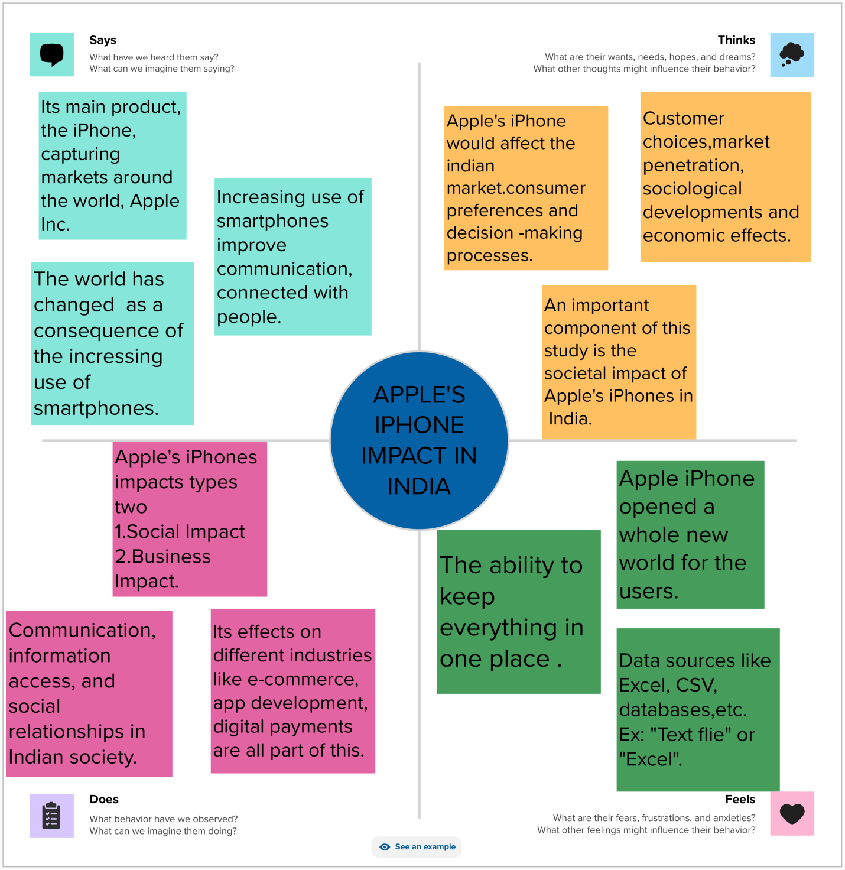

**2.2** **IDEATION & BRAINSTORMING MAP**:

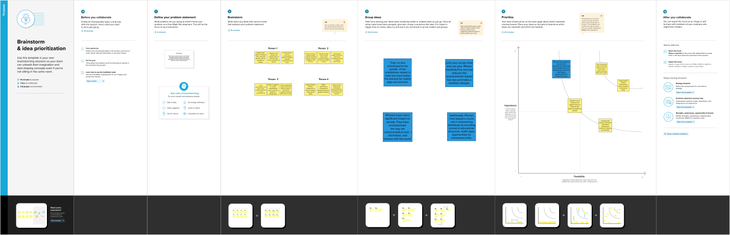3**.RESULT**:

**3.1 DASHBOARD**: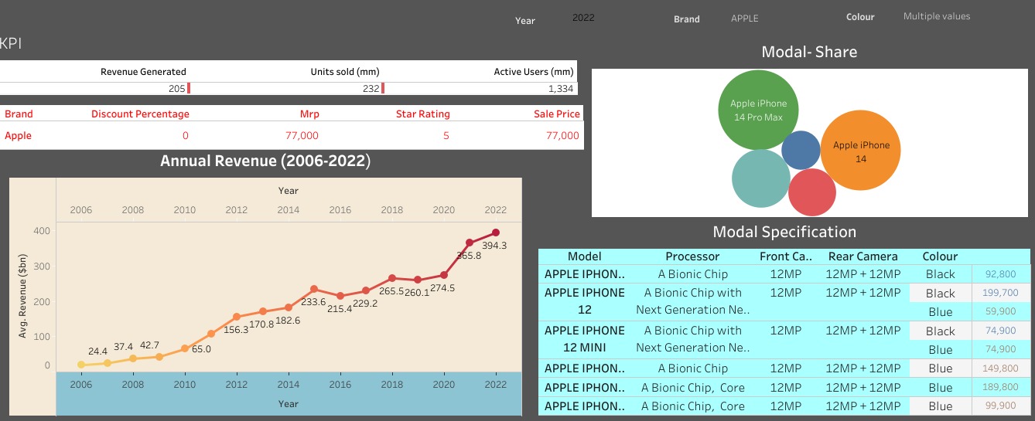

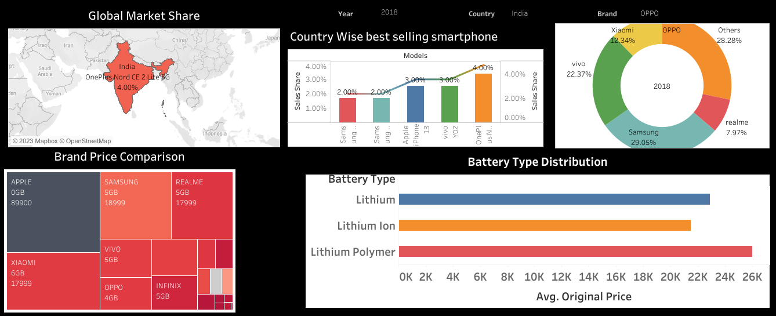

**3.2 STORY**: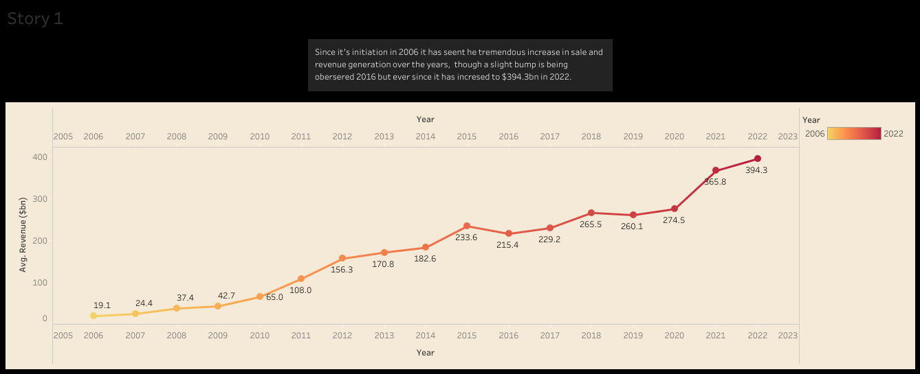

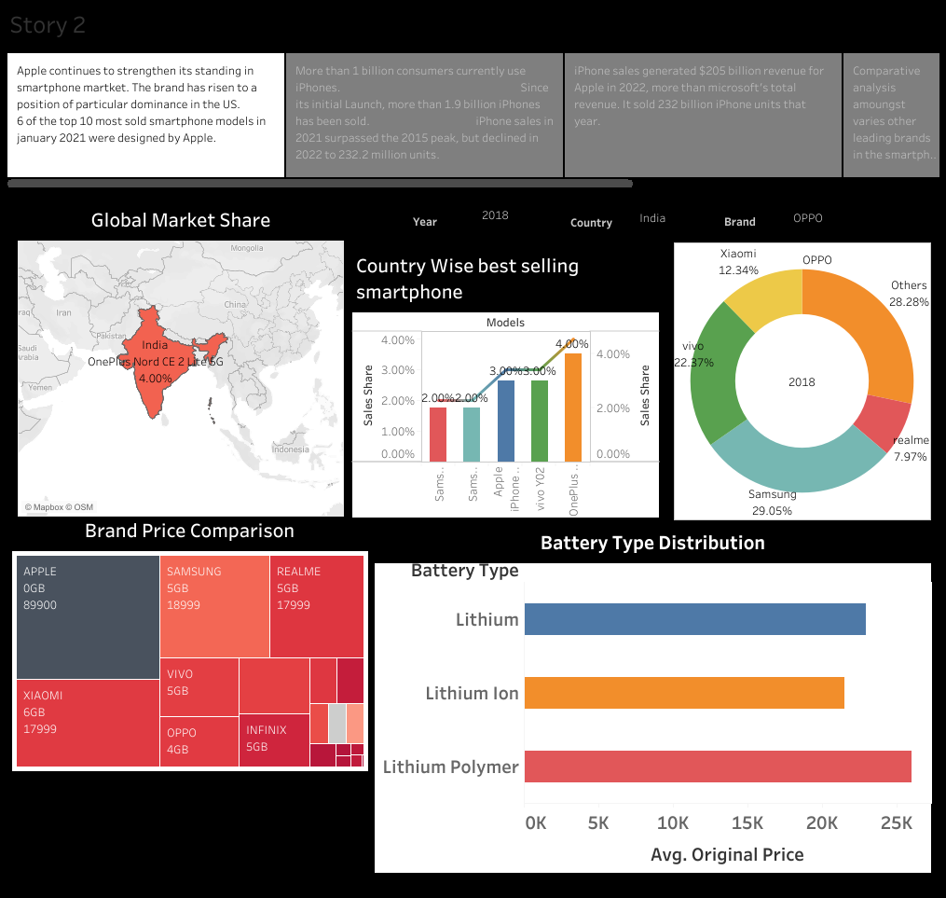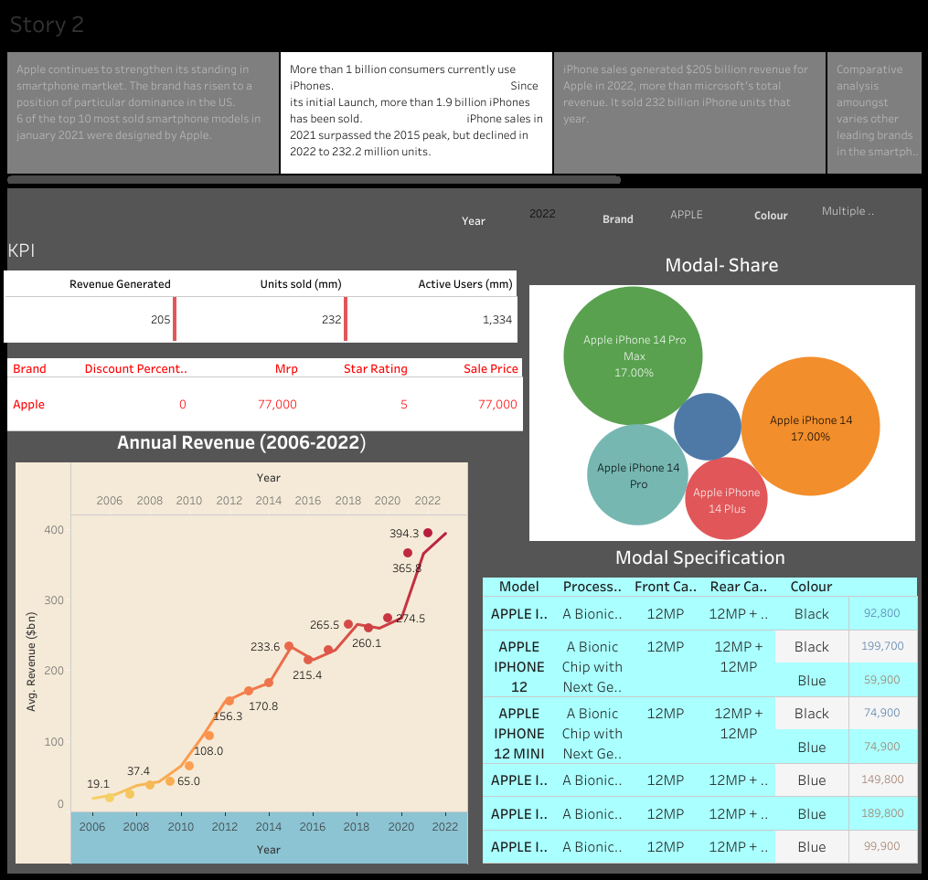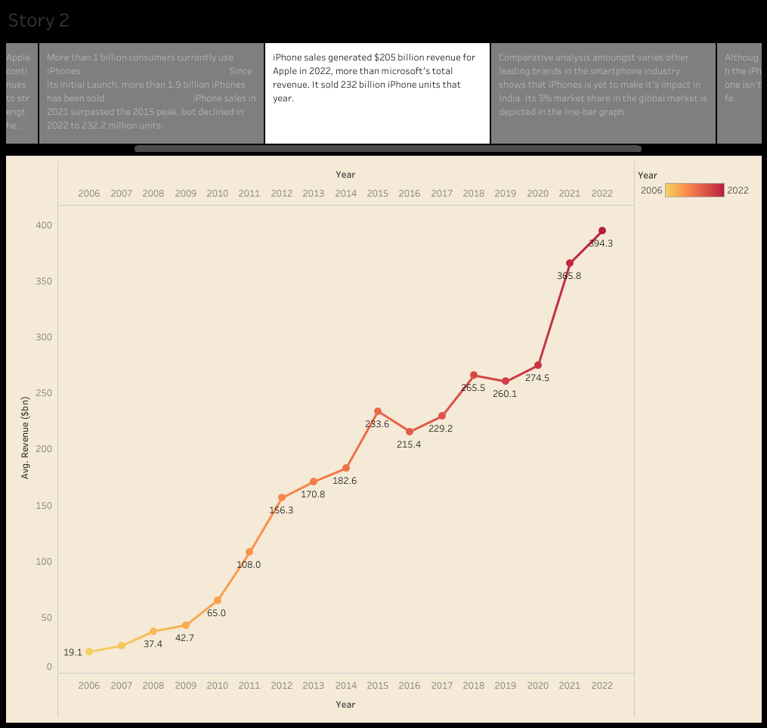

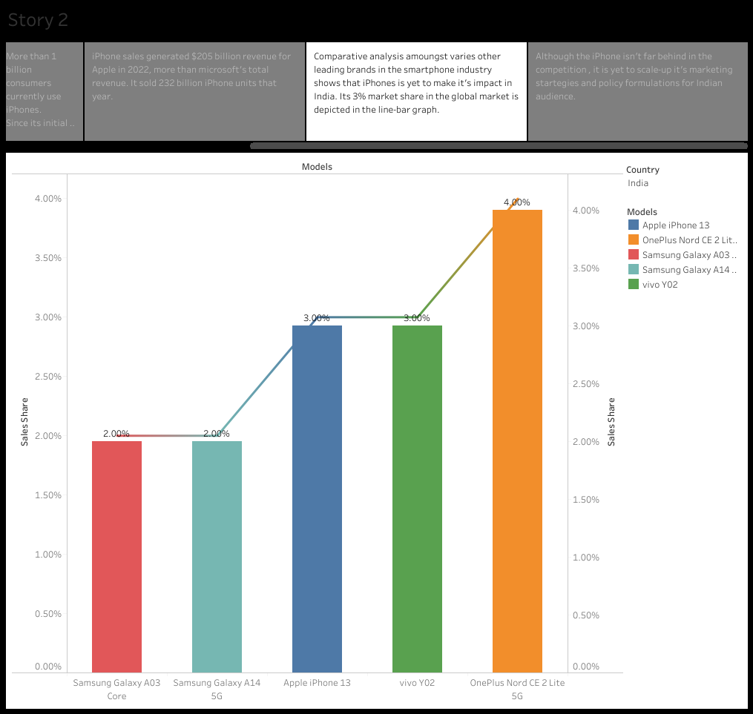

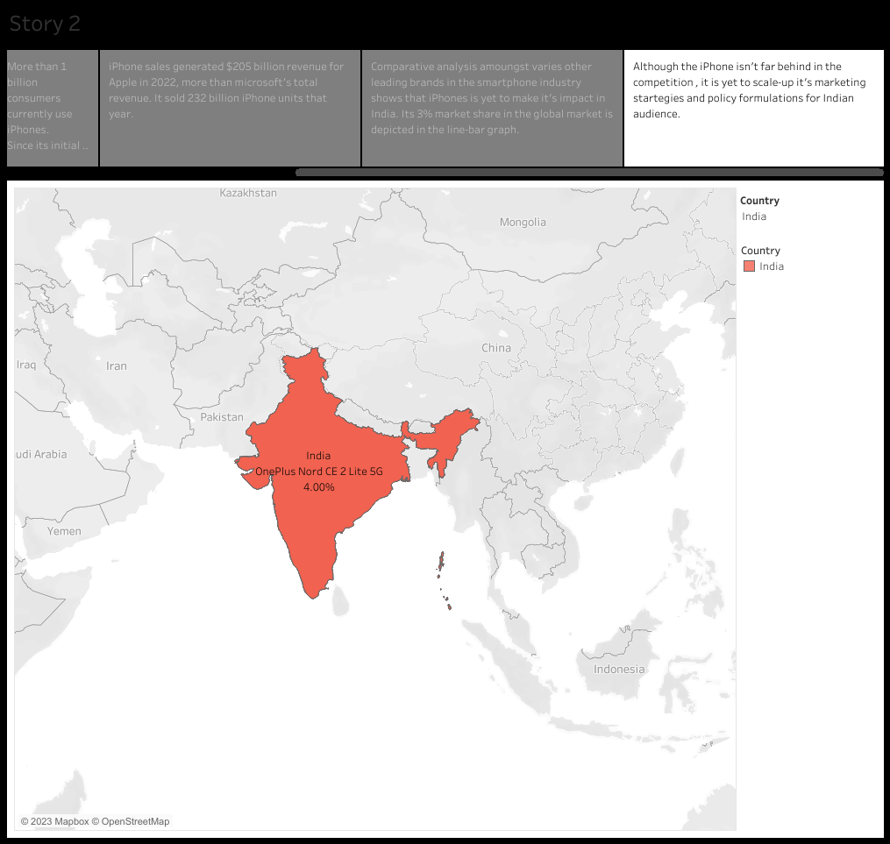

**4 .ADVANTAGES & DISADVANTAGES**:

**4.1** **ADVANTAGES:**

* **Operating system:** iPhones use iOS, which is known for its simplicity, security, and ease of use.
* **User Interface:** iOS offers a clean and intuitive user interface, making it easy for both beginners and experienced users to navigate.
* **App Store Ecosystem:** Apple’s App Store offers a vast selection of high quality apps, ranging from productivity tools to entertainment options.
* **Integration with Apple Ecosystem:** iPhones seamlessly integrate with other apple devices, such as Macs, iPads, and apple watches, allowing for a seamless user experience across devices.
* **Privacy and Security:** Apple has a strong stance on user privacy and security, providing regular updates and encrypted data storage.
* **Accessibility Features:** iPhones offer a range of accessibility features designed to assist individuals with disabilities, ensuring a better user experience for a broader audience.
* **Resale Value:** iPhones gererally have good resale value compared to other smartphones, thanks to their brand reputation, software support, and high demand in the used market.
* **Excellent Cameras:** iPhones consistently deliver exceptional camera performance, including features like night mode, portrait mode, and advanced image processing capabilities.

**4.2 DISADVANTAGES**:

* **Cost:** iPhones tend to be more expensive compared to some Android alternatives, which can make them less accessible for budget-concious consumers.
* **Customization:** iOS limits customization options, such as homescreen layout and default apps, compared to Android devices.
* **Closed Ecosystem:** iPhones have limited interoperability with non-Apple devices and services, requiring uses to stay within the Apple ecosystem for optimal integration.
* **Storage Limitations:** Most iPhones do not offer expandable storage options, which means users many need to rely on cloud services or pay for higher-capacity models.
* **Battery Life:** While Apple has improved battery life over the years, some users still find iPhones to have shorter battery life compared to certain Android devices.
* **Limited File management:** iPhones havea limited file management system compared to some Android devices. Accessing and organizing files directly on the device can be more restricted and challenging.
* **Learning Curve:** iOS may have a different user interface and intraction paradigm compared to other operating systems. Switching from Android or other platforms may require a learning curve for new users.
* **Over-Reliance On iCloud:** Uses may need for additional iCloud storage if they exceed the free limit.

**5. APPLICATION:**

* **Social Media:** Applications like Facebook, Instagram, Twitter, Snapchat, and Tiktok are widely used for social networking, sharing photos / videos, and connecting with friends and family.
* **Communication**: Messaging and calling apps like WhatsApp, Messenger, Skype, FaceTime, and Telegram allow users to stay connected through text messages, voice calls, and video calls.
* **Productivity:** Apps such as Microsoft Office suite (Word,Excel,PowerPoint), Google Drive, Evernote, Trello, and Slack help users stay organized, manage documents, collaborate on projects, and optimize productivity.
* **Entertainment**: iPhones offer a wide variety of entertainment Apps, including streaming services like Netflix, Hulu, Disney+, Amazon Prime Video, Spotify, Apple Music, and Podcasts for movies, TV shows, music and poadcasts.
* **Games:** The Apps store has a vast collection of games across different genres, from casual puzzles and arcade games to immersive role-playing and action games.
* **Photography and Editing**: iPhones have powerful built –in cameras, and apps like Adobe Lightroom, VSCO, Snapseed, and Instagram provide additional photo editing tools and filters to enhance and share images.
* **Health and Fitness**: iPhone users can track their physical activity, monitor workouts, and manage their health.

**6.CONCLUSION:**

Apple iPhones have made a significant impact in India. While Apple initially faced challenges breaking into the Indian market due to its premium pricing and competition from other smartphone brands, it has made significant progress in recent years. Overall, Apple iPhones have had a significant impact in india, influencing consumer preferences, driving the premium smartphones segment, promoting digital payments, and stimulating the app development ecosystem. With ongoing efforts to expand their presence in the country, Apple is likely to continue shaping the Indian smartphones market in the coming years.

**7. FUTURE SCOPE:**

* **Market Growth:** India is a large and rapidly growing smartphone market. As Apple continues to focus on the Indian market, it has the potential to increase its market share further. This could be driven by factors such as competitive pricing, localized manufacturing, and strategic partnerships.
* **Mid-range iPhone Models:** Apple's introduction of mid-range iPhone models, such as the iPhone SE, has allowed the company to target a broader consumer base in India. These more affordable options could attract price-conscious consumers and lead to increased adoption of iPhones.
* **Manufacturing and Job Creation:** Apple's commitment to manufacturing iPhones in India has the potential to generate more employment opportunities and contribute to the country's "Make in India" initiative. Further expansion of manufacturing operations could lead to greater localization and cost efficiencies for Apple.
* **App and Services Ecosystem:** With the growing popularity of iPhones in India, the iOS app and services ecosystem is likely to expand. This will create more opportunities for Indian app developers and content creators, as well as enhance the overall user experience for iPhone users.
* **5G Adoption:** As India's telecom infrastructure evolves to support 5G technology, Apple's future iPhones are expected to incorporate 5G capability. This could further attract consumers looking for high-speed connectivity and improved performance.
* **Digital Payments and Services Integration:** India has witnessed a significant rise in digital payments, and Apple's ecosystem, including Apple Pay, has the potential to play a role in this space. Integrating with local payment systems and service providers could strengthen Apple's position in the digital payments market in India.
* **Augmented Reality (AR):** Apple has been investing in AR technology, and this could have an impact on various industries in India, such as education, gaming, retail, and entertainment. The adoption of AR features in future iPhone models could drive innovation and create new opportunities in these sectors.